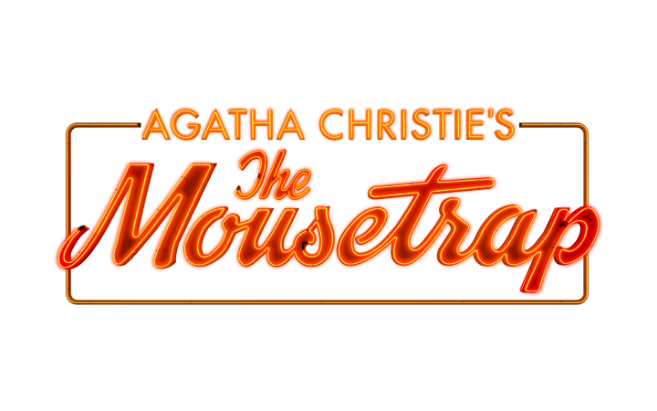
AGATHA CHRISTIE’S ICONIC THRILLER
THE MOUSETRAP
TO EMBARK ON
75TH ANNIVERSARY UK TOUR
FROM SEPTEMBER 2026
BOOKING EXTENDED IN THE WEST END
TO JANUARY 2027

London imagery can be downloaded HERE

tour imagery can be downloaded HERE

Producer, Brian Fenty, is delighted to announce that Agatha Christie’s iconic thriller and the world’s longest running play, The Mousetrap will embark on a major UK tour from September 2026 running through to 2027. The tour forms part of wider plans to celebrate The Mousetrap’s 75th anniversary year with more exciting celebrations to be announced. The West End production will also extend booking into its 75th year to 3 January 2027.

Full casting and creative team for the tour to be announced in due course.

SOLVE THEATRE'S MOST FAMOUS MYSTERY.

Since 1952, Agatha Christie’s The Mousetrap has captivated the world with silent clues, shifting shadows and the best kept secret in theatre history. Now, the record-breaking classic embarks on its 75th Anniversary Tour across the UK and Ireland.

A shocking murder rattles London. Far from the chaos, a remote country guesthouse welcomes seven strangers seeking refuge. But when a police sergeant battles through a deadly snowstorm with a warning no one expects, it becomes clear the threat is already within their walls.

Every whisper hides a clue. Every story masks a lie. And as suspicion tightens its grip, one question chills the room: Who among them is capable of murder?

Step inside, and solve the greatest murder mystery that has kept the world guessing for generations.

THE MANOR AWAITS.

Earlier this year the play celebrated its 30,000th performance in the West End and was presented with a Guinness World Records certificate for the record title longest theatrical run. The genre-defining murder mystery opened in 1952 and continues to enthral audiences at London’s St Martin’s Theatre, now booking into its 75th year in 2027.

The Mousetrap is produced by Brian Fenty.

The London production at St Martin's Theatre is directed by Ola Ince with artistic direction by Denise Silvey.

Website: www.themousetrap.com
Twitter: @TheMousetrapOfficial
Facebook: @TheMousetrapOfficial
Instagram: @TheMousetrapOfficial

WEST END LISTINGS INFORMATION

The Mousetrap
St Martin’s Theatre,
West St,
London WC2H 9NZ

Ticket Prices from: £25
Current Booking Period: 3 January 2027
Running Time: 2hrs including interval

Performances:
Monday to Saturday at 7.30pm
Tuesday, Thursday & Saturday at 3.00pm.

CHRISTMAS 2025 WEST END PERFORMANCE SCHEDULE

Monday 22 December at 3pm & 7.30pm
Tuesday 23 December at 3pm & 7.30pm
Wednesday 24 December – No performance
Thursday 25 December – No performance
Friday 26 December at 7:30pm
Saturday 27 December at 3pm & 7.30pm
Sunday 28 December – No performance
Monday 29 December at 3pm & 7.30pm
Tuesday 30 December at 3pm & 7.30pm
Wednesday 31 December at 2pm
Thursday 1 January at 7.30pm
Friday 2 January at 3pm & 7.30pm
Saturday 3 January at 3pm & 7.30pm
Sunday 4 – No performance

2026/27 TOUR SCHEDULE

3 – 12 Sept 2026 Birmingham, The Alexandra
atgtickets.com/Birmingham

15 – 19 Sept Princess Theatre, Torquay
atgtickets.com/torquay

21 – 26 Sept Everyman Theatre, Cheltenham 01242 572 573
everymantheatre.org.uk

28 Sept – 3 Oct Malvern Theatres 01684 892277
malvern-theatres.co.uk

5 – 10 Oct Lyceum Theatre, Crewe
trafalgartickets.com/lyceum-theatre-crewe/en-GB

12 – 17 Oct Theatre Royal Windsor 01753 853 888
theatreroyalwindsor.co.uk

19 – 24 Oct Floral Pavillion, New Brighton
floralpavilion.com

26 – 31 Oct Manchester Opera House
atgtickets.com/manchester

2 – 7 Nov Lyceum Theatre, Sheffield
sheffieldtheatres.co.uk

9 – 14 Nov Aylesbury, Waterside
atgtickets.com/Aylesbury

16 – 21 Nov Devonshire Park Theatre, Eastbourne
trafalgartickets.com/eastbourne-theatres-eastbourne/en-GB

23 – 28 Nov Lighthouse Poole
lighthousepoole.co.uk

30 Nov – 5 Dec Palace Theatre, Southend
trafalgartickets.com/palace-theatre-southend/en-GB

7 – 16 Jan 2027 Royal & Derngate, Northampton 01604 624811
royalandderngate.co.uk

19 – 23 Jan Cardiff New Theatre 0343 310 0041
newtheatrecardiff.co.uk

25 – 30 Jan Woking New Victoria Theatre
atgtickets.com/new-victoria-theatre

1 – 6 Feb Theatre Royal Plymouth 01752 267 222
theatreroyal.com

15 – 20 Feb Bromley Churchill Theatre 0343 310 0020
churchilltheatre.co.uk

22 – 27 Feb Swindon Wyvern Theatre 0343 310 0040
swindontheatres.co.uk

1 – 6 March Stoke, Regent Theatre
atgtickets.com/stoke

8 – 13 March Lichfield Garrick
lichfieldgarrick.com

22 – 27 March Sunderland Empire Theatre
atgtickets.com/sunderland

5 – 10 April Edinburgh Playhouse
atgtickets.com/Edinburgh

12 – 17 April Glasgow Kings Theatre
atgtickets.com/Glasgow

26 April – 1 May Milton Keynes Theatre
atgtickets.com/miltonkeynes

24 – 29 May Truro Hall for Cornwall 01872 262 466
hallforcornwall.co.uk

21 – 26 June Grand Opera House York
atgtickets.com/York

Further venues to be announced

